Team Meeting - 2/13

**Agenda**

1. Brainstorm quantitative and subjective/qualitative requirements for our ATR and Map Generation system
2. Keep in mind categories such as requirements analysis, specification (quantitative requirements should be defined in inequalities), validation, and verification
3. Run through requirement compromise schematics
4. Consider assembling high-level outline of requirements into a product engineering specification request (PSR) document
5. Present ideas on requirements decision matrices

**Notes**

* A sample deliverable for Requirements Definition presentation has been uploaded to the “Deliverables/Week_5” subfolder

**Requirement Classifications**

1. **Generic Statement:** The Aircraft Design Team and project program managers want a mounted zoom camera that is located near the middle of the vehicle to minimize reduction in structural/flight performance of the aircraft. It should be able to continuously capture video footage of the AOI during the Search phase of motion.
2. **Subjective Technical Requirements**

* Camera satisfies aircraft weight requirement
* Position of camera at most, marginally impacts vehicle’s center of gravity
* Ability to access PTZ coordinates of camera to better predict GPS location of targets
* Camera that has servo that allows for it to rotate
* Camera should have capabilities of capturing video feed with acceptable resolution from cruise altitude
* Video feed output should be of an acceptable file format (likely .mov) that can be interpreted by image processing software (likely OpenCV, OrbSLAM - less documentation)
* Camera should be designed with two or more output ports (likely micro USB or micro HDMI) for transmitting video feed to video transmitters in Ground Control and to OpenCV software in Raspberry Pi

1. **Quantitative Requirements**

* Quantitative weight range?? (Communicate with Aircraft Design Team) - Maybe 16 lbs total weight (Currently sitting at 12lbs, (check recording))
* Quantifiable restrictions to in-flight mounted position of camera and location of aircraft’s center of gravity?
* Operating range of altitude for camera to capture video feed of desirable resolution (>200 ft)?

1. **Generic Statement:** The Aircraft Design Team and project program managers want an automated target recognition system to be able to use the video feed to classify TOI in images captured by the camera. It is necessary for these images to be stored with their GPS locations, and transmitted to the Mission Planner software and Payload Drop Team so that the aircraft can successfully navigate to affected areas and drop ADP during the Surveillance phase of motion.
2. **Subjective Technical Requirements**

* Automated target recognition system (likely OpenCV) should be designed to read in video data of format output by mounted zoom camera (.mov)
* The ATR system should be able to read input from Autopilot to tag images with their associated GPS locations
* ATR system should be able to extract individual image frames from continuous video files and temporarily store images in a job queue (database) to await processing
* ATR system should be able to pull from job queue to process each image individually
* ATR system should be loaded onto an in-flight mounted co-processor (Raspberry Pi) to optimize transmission of information from camera through to the algorithm used by Payload Drop Team according to time
* What file formats should the GPS coordinates and generated map be stored in?
* Recommended number of training images for our computer vision model to train on: 1000

1. **Quantitative Requirements**

* Need information on what the image processing algorithms will look like. How much local memory they will consume when executed, and limitations associated with having image processing algorithms and algorithms for generating map and for use by Payload Drop Team on same co-processor
* Are there restrictions to the memory of the CPU on the Raspberry Pi?
  + We should get the 4GB one to be safe
* Can we quantify the size in which each video file should be broken down into image frames and what the processing rate of these images should be?
* Can we quantify the physical dimensions of the Raspberry Pi, GPS module, and desirable distances between Raspberry Pi - GPS module, Pixhawk Autopilot-GPS module, and Raspberry Pi - Pixhawk Autopilot?
* How much power needs to be supplied to the raspberry pi from the aircraft’s battery
  + At least 5v and 3 amps over usb connection
* Algorithm has to identify 6 targets in 4 minutes

1. Generic Statement: The Aircraft Design Team has specifications on physical and weight dimensions for the UAS as a whole
2. Subjective Technical Requirements
3. Quantitative Requirements

* Total Aircraft Weight Requirement: ~16 lbs
* Base weight with optimal propulsion pack, AV kit, new wing, ADPS, etc) is about 12 lbs

**Design Compromise Schematic**







**Generated Map Flexibility/Application**

* **Quantity and Quality of UI Features**
* **RAM of Co-Processor**







**Decision Matrix**



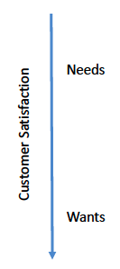

| 1. Collecting video feed of AOI and GPS coordinates 2. Generating map of field given classifications and GPS locations 3. Transmitting generated map to the AFD | 1) Refining the GPS coordinates to get more accurate target locations  2) Classifying the TOI’s as critical and non-critical |
| --- | --- |
| 1. Identifying static/simple features (ex: trees, grass, ponds), from AOI 2. Incorporating interactive elements into generated map | 1) Pairing GPS coordinates with image frames from video feed  2) Designing more “efficient” target recognition algorithm that improves detection accuracy and/or optimizes runtime  3) Identifying human faces/ emotions as opposed to provided TOI’s |

**Product Engineering Specification Request**

|  |  |  |  |  |
| --- | --- | --- | --- | --- |
|  |  |  |  |  |
|  |  |  |  |  |
|  |  |  |  |  |

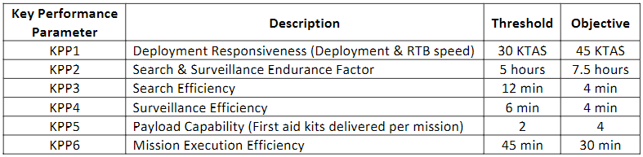

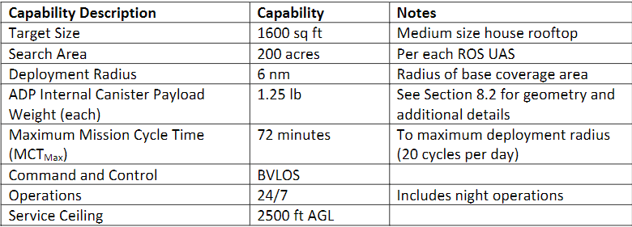

**Accomplished**

**Questions/Concerns**

1. **Does the ATR Team need to include subjective and/or quantitative requirements (ex: payload weight, aircraft physical dimensions, etc.) specific to the Aircraft Design Team in Wednesday’s deliverable?**
2. **Have a conversation with Aircraft Design Team about weight requirements (16 lbs total and 4 lbs for payload?)**